

DATABASE MANAGEMENT SYSTEM

PROJECT REPORT

HOSTEL MANAGEMENT SYSTEM

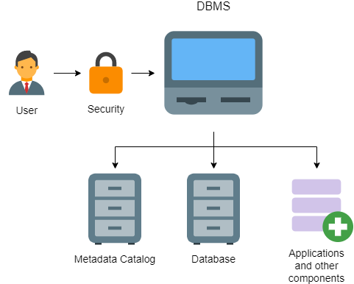

BY- TANMAY PAWAR (2022UCA1850)

**DBMS PROJECT**

**HOSTEL MANAGEMENT SYSTEM**

INTRODUCTION

* 1. Introduction of the Problem Area

Hostel Management System (HMS) stands as a very vital solution that will benefit both students and administrative bodies of NSUT. Currently, the management of hostel-related activities relies on manual and Out-of-date tech processes. This software aims to streamline and modernize these operations.

Our Hostel Management System entails a wide range of functionalities, focusing on the administration of student accommodations, staff oversight, hostel facilities, and room allocations. “Users” can register under two main categories: students and staff members, each with distinct access levels of permissions.

For students, the system enables easy access to their hostel related info, room allocation, and overall hostel facilities. Additionally, administrative functionalities like room assignment, maintenance of staff records, and hostel amenities management are integrated into the system.

Limitations in the current system prompt the need for this digital transformation:

* Out-of-date Data Entry: Time-intensive data entry processes lead to inefficiencies.
* Paper-Based Records: Extensive paperwork contributes to storage challenges and accessibility issues. E.g. student attendance is taken on paper.
* Reliability: Relying on paper-based systems poses risks to the security and reliability of valuable data.
* Platform: There is no platform to raise hostel related complaints directly.

The Hostel Management System for NSUT Hostels aims to eliminate these limitations, ensuring a more streamlined, efficient, and reliable management system for student accommodations, staff oversight, and hostel facilities.

* 1. Problem Statement/Purpose of the Project  
     The primary objective of this project is to establish a robust Hostel Management System capable of storing student records and allowing queries. This database system will streamline administrative tasks, offer a “user” friendly interface and reducing time spent on these functions! Accessible with an internet connection, the system enables accurate processes and report generation at any time.

Theis system aims to deliver enhanced services, like consistent and timely data access all on an electronic interface/medium. Using a stack comprising XAMPP, VS Code, and web-based technologies such as HTML, PHP, JavaScript, CSS, and MySQL, and the user interface was built using HTML, PHP, JavaScript, and CSS, while MySQL.

We made the system step by step to make it strong and work well. And we're thinking about making it even better later on for NSUT. So, it can change and grow with NSUT!  
  
Level Design  
  
Administrator level:  
Everything is fully editable.  
  
User level:  
Every personalized data is view only.  
Students/staff can update grievances and complaints.

* 1. Project Objectives for NSUT’s Hostel Management System

• Creating an efficient, streamlined, and error-free digital infrastructure.

• Eliminating data redundancy to ensure accuracy and flexibility within the system.

• Studying and understanding the intricate workings of hostel management within NSUT.

• Prioritizing speed and a robust user interface for swift and enduring performance.

• Establishing a centralized database for both students and staff involved in hostel management.

• Utilizing computerization to optimize time and cost efficiency.

• Minimizing the risk of information leaks through stringent security measures like login and password protection.

• Enabling swift storage and retrieval of data and information when needed.

• Streamlining student coordination and administrative arrangements.

• Drastically reducing the dependency on paperwork, transitioning to a digital ecosystem

* 1. **Requirement analysis**

**Hostel Resident Details:**

Capture comprehensive resident information: personal details, room allocation, etc.

Allow easy modification and access control for privacy and security.

Access controls ensuring only authorized personnel can view or modify resident details for privacy and security.

**Hostel Staff Details:**

Manage staff information: roles, schedules, assigned areas, and responsibilities.

Different access levels for staff and administrators.

**Mess Menus:**

Display and update meal plans for each hostel's mess.

Allow feedback and modifications to improve meal planning.

**Washing Machines:**

Record machine details, usage, and maintenance history.

Tracking the usage of washing machines for better upkeep.

HARDWARE SOFTWARE REQUIREMENTS

**Hardware requirements :**

1. The hardware requirements to build a website are RAM suitable of 16GBs , operating software , usually Linux is preferred , and large memory storage space .
2. To host the website , a server machine is required to load the website on a domain .

Software requirements :

1. A text editor to write scripting language that will build the structure , functioning , and styling of the webpage .
2. extensive knowledge of coding languages to build a website that contains both frontend and backend of a website

The languages used in the making of the project are :

* + - * HTML (structuring of the website)
      * CSS (used for styling )
      * Javascript (used for the functionality of the web page)
      * PHP ( used for storing input data into the database)
      * XAMPP( used for creating and structuring the tables and relations of the backend )

1. A browser to display the website (preferred GOOGLE CHROME)

ER MODEL

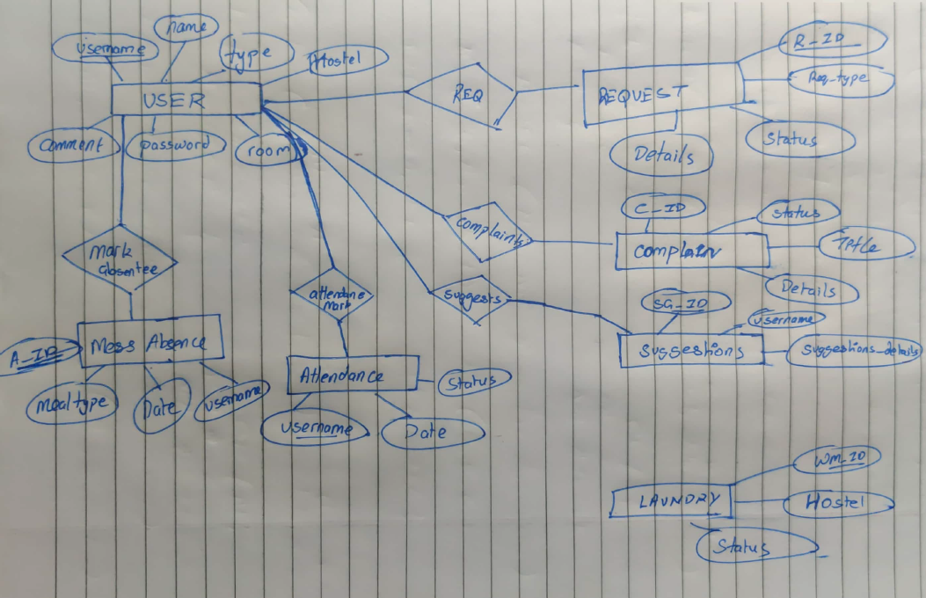

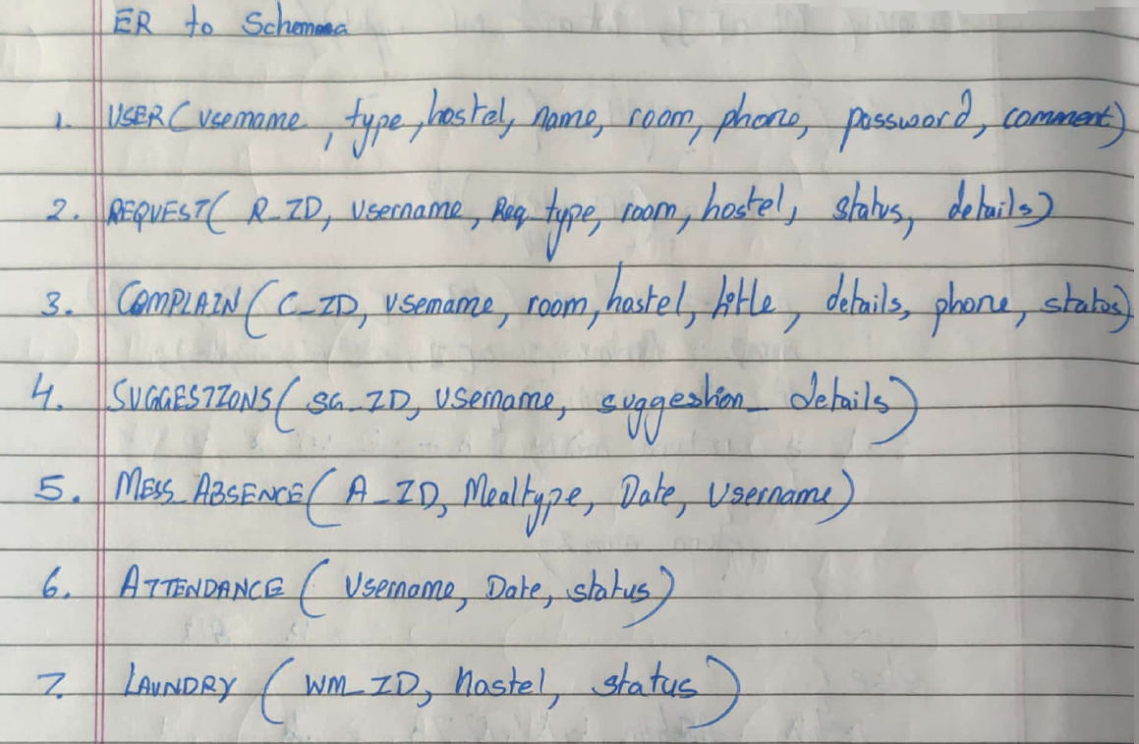

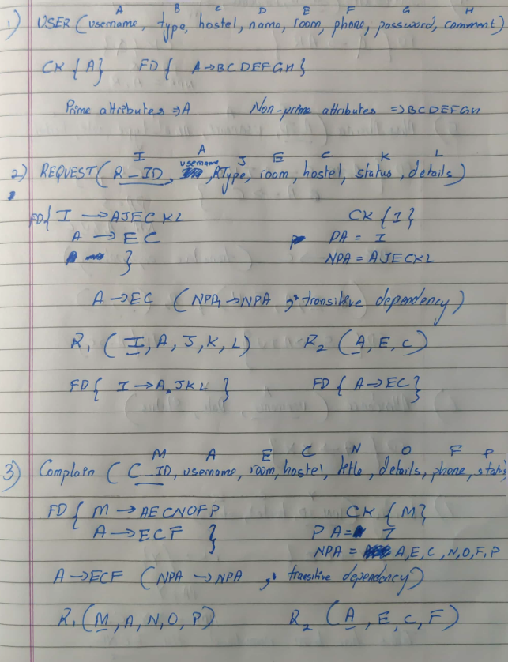

XAMPP TABLES

1. USER :

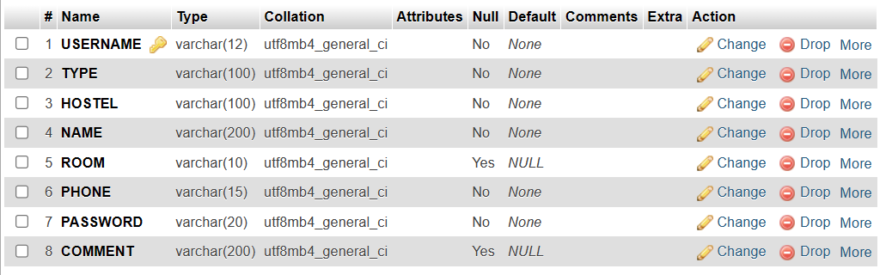

1. REQUEST:

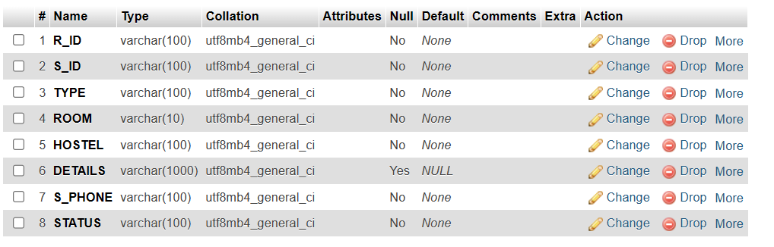

1. COMPLAIN :

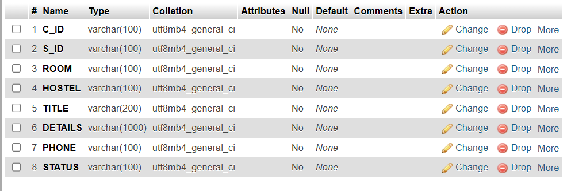

1. SUGGESTIONS: 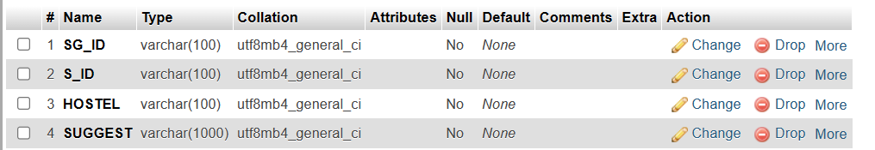
2. ATTENDANCE :

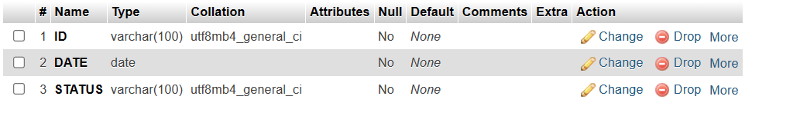

1. MESS ABSENCE:

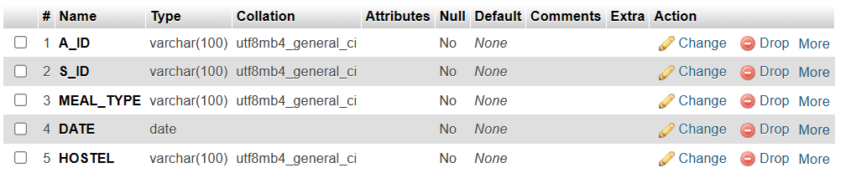

1. LAUNDRY:

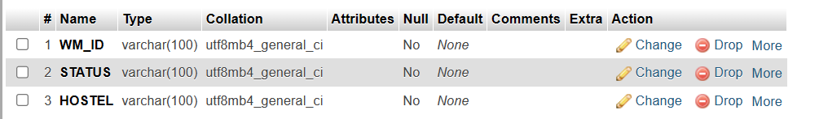

CODES

Login.html:

<html lang="en">

<head>

    <meta charset="UTF-8">

    <meta name="viewport" content="width=device-width, initial-scale=1.0">

    <title>NSUT|Hostel</title>

    <link rel="stylesheet" href="login.css">

    <link rel="stylesheet" href="https://fonts.googleapis.com/css?family=Trirong">

</head>

<body>

    <img src="http://nsut.ac.in/sites/default/files/logo_nsut_0_0_0_0.png" alt="" class="center">

    <h1>Welcome to NSUT Hostel Portal</h1>

    <h2 class="login">Login</h2>

    <form action="login.php" method="post" class="form">

        Username : <input type="text" name="username" id="">

        Password : <input type="password" name="password" id="">

        <input type="submit" name="" id="">

    </form>

    <a href="newuser.html" class="new">New User? Create Account</a>

    <div id="square"> </div>

    <br><br>

    <div class="weatherInfo"></div>

    <script src="weather.js"></script>

</body>

</html>

Login.php:

<html>

<?php

$user  = $_POST["username"];

$pass = $_POST["password"];

$found = false;

$servername = "localhost";

$username = "root";

$password = "";

$dbname = "hostel";

// Create connection

$conn = new mysqli($servername, $username, $password, $dbname);

// Check connection

if ($conn->connect_error) {

  die("Connection failed: " . $conn->connect_error);

}

$sql = "SELECT * FROM User";

$result = $conn->query($sql);

$userlist = array();

if ($result->num_rows > 0) {

  while($row = $result->fetch_assoc()) {

    $username = $row["USERNAME"];

    $password = $row["PASSWORD"];

    $type = $row["TYPE"];

    $hostel = $row["HOSTEL"];

    $name = $row["NAME"];

    $room = $row["ROOM"];

    $phone = $row["PHONE"];

    $userlist[$username] = array($type,$hostel,$name,$room,$phone);

    if ($username===$user){

        $found=true;

        if($password!==$pass){

            $found=false;

        }

        break;

    }

}

}

if (!$found){

    echo "Invalid Credentials";

}

else{

    echo "ID Number : ".$username."<br>";

    echo "Name : ".$userlist[$username][2]."<br>";

    echo "Account type : ".$userlist[$username][0]."<br>";

    echo "Hostel : ".$userlist[$username][1]."<br>";

    echo "Room : ".$userlist[$username][3]."<br>";

    echo "Phone : ".$userlist[$username][4]."<br>";

    if ($userlist[$username][0] === 'Student') {

        session_start();

    $username = $user;

    $_SESSION['username'] = $username;

    echo "<a href='student.php?data=$username'>Continue</a><br>";

    echo '<a href="logout.php">Logout</a>';

    exit();

    }

    elseif ($userlist[$username][0] === 'Staff-Admin') {

        session_start();

    $username = $user; // Replace with the actual username

    $_SESSION['username'] = $username;

        header("Location: admin.html");

        exit;

    }

    elseif ($userlist[$username][0] === 'Staff-Housekeeping/Maintenance') {

        session_start();

    $username = $user; // Replace with the actual username

    $_SESSION['username'] = $username;

        header("Location: staffhm.html");

        exit;

    }

}

$conn->close();

?>

</html>

Logout.php

<?php

session_start();

$_SESSION = array();

session_destroy();

header("Location: login.html");

exit();

?>

Newuser.html

<html lang="en">

<head>

    <meta charset="UTF-8">

    <meta name="viewport" content="width=device-width, initial-scale=1.0">

    <title>Create Account</title>

</head>

<body>

    <form action="newuser.php" method="post">

        ID Number: <input type="text" name="id" id=""> <br>

        Name : <input type="text" name="name" id=""> <br>

        Account Type : <select name="type" id="type">

            <option value="Student">Student</option>

            <option value="Staff-Admin">Staff-Admin</option>

            <option selected value="Staff-Housekeeping/Maintenance">Staff-Housekeeping/Maintenance</option>

        </select> <br>

        Hostel : <select name="hostel" id="hostel">

            <option value="JC BOSE">JC BOSE</option>

            <option value="Ramanujan">Ramanujan</option>

            <option value="Raman">Raman</option>

            <option value="Bhaskara">Bhaskara</option>

            <option value="Aryabhatta">Aryabhatta</option>

            <option value="Alaknanda">Alaknanda</option>

            <option value="Saraswati">Saraswati</option>

            <option value="Kaveri">Kaveri</option>

        </select> <br>

        Room Number : <input type="text" name="room" id=""> <br>

        Phone : <input type="number" name="number" id=""> <br>

        Enter a password : <input type="text" name="passwd" id="">

        <br>

        <input type="submit" name="" id="">

    </form>

</body>

</html>

<html>

<?php

$use = $_POST["id"];

$passwd = $_POST["passwd"];

$type = $_POST["type"];

$hostel = $_POST["hostel"];

$name = $_POST["name"];

$room = $_POST["room"];

$phone = $_POST["number"];

$comment = "";

$servername = "localhost";

$username = "root";

$password = "";

$dbname = "hostel";

$conn = new mysqli($servername, $username, $password, $dbname);

if ($conn->connect_error) {

  die("Connection failed: " . $conn->connect_error);

}

$sql = "INSERT INTO USER values('$use','$type','$hostel','$name','$room','$phone','$passwd','$comment')";

$conn->query($sql);

$conn->close();

echo "User Added Successfully"

?>

<a href="Login.html">Return to Login Page</a>

</html>

Student.php:  
<html lang="en">

<head>

    <meta charset="UTF-8">

    <meta name="viewport" content="width=device-width, initial-scale=1.0">

    <title>Hostel Portal</title>

</head>

<body>

<?php

    echo "<a href='Staff.php'>Staff Details</a> <br>";

    echo "<a href='MessMenu.png'>Mess Menu</a> <br>";

    echo "<a href='../request.php'>Raise a Request</a> <br>";

    echo "<a href='../complain.php'>Raise a Complaint</a> <br>";

    echo "<a href='../attendance.php'>Mark Attendance</a> <br>";

    echo "<a href='../MessAbsence.php'>Confirm Messs Absence</a> <br>";

    echo "<a href='../laundry.php'>Check Laundry Status</a> <br>";

    echo "<a href='../suggestion.php'>Suggestions</a> <br>";

    echo '<a href="../logout.php">Logout</a>';

    ?>

</body>

</html>

Staff.php

<html lang="en">

<head>

    <meta charset="UTF-8">

    <meta name="viewport" content="width=device-width, initial-scale=1.0">

    <title>Raman | Staff Details</title>

</head>

<body>

    <?php

$servername = "localhost";

$username = "root";

$password = "";

$dbname = "hostel";

// Create connection

$conn = new mysqli($servername, $username, $password, $dbname);

// Check connection

if ($conn->connect_error) {

  die("Connection failed: " . $conn->connect_error);

}

$sql = "SELECT * FROM User";

$result = $conn->query($sql);

$userlist = array();

if ($result->num_rows > 0) {

  while($row = $result->fetch_assoc()) {

    $username = $row["USERNAME"];

    $password = $row["PASSWORD"];

    $type = $row["TYPE"];

    $hostel = $row["HOSTEL"];

    $name = $row["NAME"];

    $room = $row["ROOM"];

    $phone = $row["PHONE"];

    $comm = $row["COMMENT"];

    $userlist[$username] = array($type,$hostel,$name,$room,$phone,$comm);

    if (($type == "Staff-Admin" || $type == "Staff-Housekeeping/Maintenance") && $hostel=="Raman") {

        echo "Name : ".$name."<br>";

        echo "Room : ".$room."<br>";

        echo "Phone : ".$phone."<br><br><br>";

}

}

}

?>

</body>

</html>

Request.html:

<html lang="en">

<head>

    <meta charset="UTF-8">

    <meta name="viewport" content="width=device-width, initial-scale=1.0">

    <title>Hostel Request</title>

</head>

<body>

    <form action="request.php" method="POST">

        Request type : <select name="Reqtype" id="">

            <option value="Housekeeping">Housekeeping</option>

            <option value="Maintenance">Maintenance</option>

        </select>

        <br>

        Details : <input type="text" name="details" id="">

        <input type="submit" name="" id="">

    </form>

    <p><?php echo $variableFromPHP; ?></p>

</body>

</html>

Request.php

<html>

<h1>Request Service</h1>

    <p>Place your request here and give elaborate details.</p>

    <p>Housekeeping requests will be serviced on the same/next day.</p>

    <p>Maintenance Requests will be serviced within 3 working days.</p>

    <br>

    <br>

<form action="<?php echo $_SERVER['PHP_SELF']; ?>" method="POST">

        Request type : <select name="Reqtype" id="">

            <option value="Housekeeping">Housekeeping</option>

            <option value="Maintenance">Maintenance</option>

        </select>

        <br>

        Details : <input type="text" name="details" id=""><br><br>

        <input type="submit" name="submit" id="">

</form>

<?php

if (isset($_POST['submit'])){

  session_start();

  $username = $_SESSION['username'];

$ReqType = $_POST["Reqtype"];

$Detail = $_POST["details"];

$servername = "localhost";

$user = "root";

$password = "";

$dbname = "hostel";

// Create connection

$conn = new mysqli($servername, $user, $password, $dbname);

// Check connection

if ($conn->connect_error) {

  die("Connection failed: " . $conn->connect_error);

}

$sql = "SELECT COUNT(*) as count FROM request";

$result1 = $conn->query($sql);

if ($result->num_rows > 0) {

    // Fetch the result as an associative array

    $row = $result1->fetch_assoc();

    // Get the count from the associative array

    $Count = $row['count'];

}

$Count++;

$sql = "SELECT * FROM USER";

$result = $conn->query($sql);

$userlist = array();

if ($result->num_rows > 0) {

  while($row = $result->fetch_assoc()) {

    $use = $row["USERNAME"];

    if ($use === $username){

    $password = $row["PASSWORD"];

    $type = $row["TYPE"];

    $hostel = $row["HOSTEL"];

    $name = $row["NAME"];

    $room = $row["ROOM"];

    $phone = $row["PHONE"];

    $userlist[$use] = array($type,$hostel,$name,$room,$phone);

    break;

    }

}

}

$room=$userlist[$use][3];

$hostel=$userlist[$use][1];

$phone=$userlist[$use][4];

$sql = "INSERT INTO Request VALUES('$Count','$use','$ReqType','$room','$hostel','$Detail','$phone','')";

$conn->query($sql);

echo "Request placed Successfully<br>";

echo "<a href=Raman/student.php>Go to Home Page</a>";

$conn->close();

}

    ?>

</html>

Complain.php:

<html>

<h1>Register Your Complain</h1>

    <p>Place your Complain here and give elaborate details.</p>

    <br>

    <br>

<form action="<?php echo $_SERVER['PHP_SELF']; ?>" method="POST">

        <br>

        Title : <input type="text" name="title"><br>

        Details : <input type="text" name="details" id=""><br><br>

        <input type="submit" name="submit" id="">

</form>

<?php

if (isset($_POST['submit'])){

  session_start();

  $username = $_SESSION['username'];

$Title = $_POST["title"];

$Detail = $_POST["details"];

$servername = "localhost";

$user = "root";

$password = "";

$dbname = "hostel";

// Create connection

$conn = new mysqli($servername, $user, $password, $dbname);

// Check connection

if ($conn->connect_error) {

  die("Connection failed: " . $conn->connect_error);

}

$sql = "SELECT * FROM USER";

$result = $conn->query($sql);

$userlist = array();

$sql = "SELECT COUNT(*) as count FROM complain";

$result1 = $conn->query($sql);

if ($result->num_rows > 0) {

    // Fetch the result as an associative array

    $row = $result1->fetch_assoc();

    // Get the count from the associative array

    $Count = $row['count'];

}

$Count++;

if ($result->num_rows > 0) {

  while($row = $result->fetch_assoc()) {

    $use = $row["USERNAME"];

    if ($use === $username){

    $password = $row["PASSWORD"];

    $type = $row["TYPE"];

    $hostel = $row["HOSTEL"];

    $name = $row["NAME"];

    $room = $row["ROOM"];

    $phone = $row["PHONE"];

    $userlist[$use] = array($type,$hostel,$name,$room,$phone);

    break;

    }

}

}

$room=$userlist[$use][3];

$hostel=$userlist[$use][1];

$phone=$userlist[$use][4];

$sql = "INSERT INTO Complain VALUES('$Count','$use','$room','$hostel','$Title','$Detail','$phone')";

$conn->query($sql);

echo "Complain placed Successfully<br>";

echo "<a href=Raman/student.php>Go to Home Page</a>";

$conn->close();

}

    ?>

</html>

Attendance.php :

<?php

$servername = "localhost";

$username = "root";

$password = "";

$dbname = "hostel";

$conn = new mysqli($servername, $username, $password, $dbname);

if ($conn->connect_error) {

    die("Connection failed: " . $conn->connect_error);

}

if ($_SERVER["REQUEST_METHOD"] == "POST") {

    $status = $_POST["status"];

    session_start();

    $student_id = $_SESSION['username'];

    $date = date("Y-m-d");

    $check_query = "SELECT * FROM attendance WHERE id = '$student_id' AND date = '$date'";

    $result = $conn->query($check_query);

    if ($result->num_rows > 0) {

        echo "Attendance already marked for today.";

    } else {

        // Insert new attendance record

        $insert_query = "INSERT INTO attendance VALUES ('$student_id', '$date', '$status')";

        if ($conn->query($insert_query) === TRUE) {

            echo "Attendance marked successfully.";

        } else {

            echo "Error: " . $insert_query . "<br>" . $conn->error;

        }

    }

}

// Close the database connection

$conn->close();

?>

<!DOCTYPE html>

<html lang="en">

<head>

    <meta charset="UTF-8">

    <meta name="viewport" content="width=device-width, initial-scale=1.0">

    <title>Mark Attendance</title>

</head>

<body>

    <h2>Mark Attendance</h2>

    <form method="post" action="<?php echo $_SERVER["PHP_SELF"]; ?>">

        Status : <select name="status" id="">

            <option value="Present">Present</option>

            <option value="Absent">Absent</option>

        </select>

        <input type="submit" value="Mark Attendance">

    </form>

</body>

</html>

MessAbsence.php:

<html>

<h1>Mark your Mess Absence</h1>

    <p>Inorder to avoid food wastage,If you have planned to not eat in the mess, kindly fill this confirmation so that less food will be prepared. </p>

    <br>

    <br>

<form action="<?php echo $_SERVER['PHP_SELF']; ?>" method="POST">

        <br>

        Date : <input type="date" name="date"><br>

        Meal Type : <select name="type" id="">

            <option value="BreakFast">Breakfast</option>

            <option value="Lunch">Lunch</option>

            <option value="Evening Snack">Evening Snacks</option>

            <option value="Dinner">Dinner</option>

        </select>

            <br><br>

            <p>I hereby confirm that I will not be present in the mess for the given period</p>

            <br><br>

        <input type="submit" name="submit" id="">

</form>

<?php

if (isset($_POST['submit'])){

  session_start();

  $username = $_SESSION['username'];

$Date = $_POST["date"];

$Meal = $_POST["type"];

$servername = "localhost";

$user = "root";

$password = "";

$dbname = "hostel";

// Create connection

$conn = new mysqli($servername, $user, $password, $dbname);

// Check connection

if ($conn->connect_error) {

  die("Connection failed: " . $conn->connect_error);

}

$sql = "SELECT * FROM USER";

$result = $conn->query($sql);

$userlist = array();

if ($result->num_rows > 0) {

    while($row = $result->fetch_assoc()) {

      $use = $row["USERNAME"];

      if ($use === $username){

      $password = $row["PASSWORD"];

      $type = $row["TYPE"];

      $hostel = $row["HOSTEL"];

      $name = $row["NAME"];

      $room = $row["ROOM"];

      $phone = $row["PHONE"];

      $userlist[$use] = array($type,$hostel,$name,$room,$phone);

      break;

      }

  }

  }

$sql = "SELECT COUNT(*) as count FROM mess_absence";

$result1 = $conn->query($sql);

if ($result1->num_rows > 0) {

    $row = $result1->fetch_assoc();

    $Count = $row['count'];

}

$Count++;

$sql = "INSERT INTO mess_absence VALUES('$Count','$username','$Meal','$Date','$hostel')";

$conn->query($sql);

echo "Thank You for Choosing to Save Food.<br>";

echo "<a href=Raman/student.php>Go to Home Page</a>";

$conn->close();

}

    ?>

</html>

Laundry.php:

<html>

<h1>Laundry Status</h1>

<?php

session_start();

  $username = $_SESSION['username'];

$servername = "localhost";

$user = "root";

$password = "";

$dbname = "hostel";

$conn = new mysqli($servername, $user, $password, $dbname);

if ($conn->connect_error) {

  die("Connection failed: " . $conn->connect_error);

}

$sql = "SELECT * FROM USER";

$result = $conn->query($sql);

$userlist = array();

if ($result->num_rows > 0) {

  while($row = $result->fetch_assoc()) {

    $use = $row["USERNAME"];

    if ($use === $username){

    $password = $row["PASSWORD"];

    $type = $row["TYPE"];

    $hostel = $row["HOSTEL"];

    $name = $row["NAME"];

    $room = $row["ROOM"];

    $phone = $row["PHONE"];

    $userlist[$use] = array($type,$hostel,$name,$room,$phone);

    break;

    }

}

}

$sql = "SELECT * FROM laundry";

$result = $conn->query($sql);

if ($result->num_rows > 0) {

  while($row = $result->fetch_assoc()) {

    $wm = $row["WM_ID"];

    $status = $row["STATUS"];

    $hostel1 = $row["HOSTEL"];

    if ($hostel1==$hostel){

      echo "$wm : $status <br>";

    }

}

}

echo"<br><br>";

echo "<a href=Raman/student.php>Go to Home Page</a>";

$conn->close();

    ?>

</html>

Suggestion.php:  
<html>

<h1>Suggestion Box</h1>

    <p>Please provide your valuable Suggestion</p>

    <br>

    <br>

<form action="<?php echo $_SERVER['PHP_SELF']; ?>" method="POST">

        <br>

        Suugestion <textarea name="suggest" id="" cols="30" rows="10"></textarea>

            <br><br>

        <input type="submit" name="submit" id="">

</form>

<?php

if (isset($_POST['submit'])){

  session_start();

  $username = $_SESSION['username'];

$suggest = $_POST["suggest"];

$servername = "localhost";

$user = "root";

$password = "";

$dbname = "hostel";

$conn = new mysqli($servername, $user, $password, $dbname);

// Check connection

if ($conn->connect_error) {

  die("Connection failed: " . $conn->connect_error);

}

$sql = "SELECT * FROM User";

$result = $conn->query($sql);

$userlist = array();

if ($result->num_rows > 0) {

  while($row = $result->fetch_assoc()) {

    $use = $row["USERNAME"];

    if ($use === $username){

    $password = $row["PASSWORD"];

    $type = $row["TYPE"];

    $hostel = $row["HOSTEL"];

    $name = $row["NAME"];

    $room = $row["ROOM"];

    $phone = $row["PHONE"];

    $userlist[$use] = array($type,$hostel,$name,$room,$phone);

    break;

    }

}

}

$sql = "SELECT COUNT(*) as count FROM suggestions";

$result1 = $conn->query($sql);

if ($result1->num_rows > 0) {

    $row = $result1->fetch_assoc();

    $Count = $row['count'];

}

$Count++;

$sql = "INSERT INTO suggestions VALUES('$Count','$username','$hostel','$suggest')";

$conn->query($sql);

echo "Thank You for your valuable suggestion.<br>";

echo "<a href=Raman/student.php>Go to Home Page</a>";

$conn->close();

}

    ?>

</html>

Admin.html:

<html lang="en">

<head>

    <meta charset="UTF-8">

    <meta name="viewport" content="width=device-width, initial-scale=1.0">

    <title>Admin</title>

</head>

<body>

    <a href="view_users.php">View Student List</a> <br>

    <a href="view_req.php">View Requests</a> <br>

    <a href="view_complain.php">View Complains</a> <br>

    <a href="view_suggest.php">View Suggestions</a> <br>

    <a href="laundry_change.php">Change Laundry Status</a> <br>

    <a href="view_messabsence.php">View Mess Absence</a> <br>

    <a href="logout.php">Logout</a>

</body>

</html>

Viewusers.php:

<html>

<h1>Student List</h1>

<?php

session_start();

$user = $_SESSION['username'];

$servername = "localhost";

$username = "root";

$password = "";

$dbname = "hostel";

// Create connection

$conn = new mysqli($servername, $username, $password, $dbname);

// Check connection

if ($conn->connect_error) {

  die("Connection failed: " . $conn->connect_error);

}

$sql = "SELECT * FROM User";

$result = $conn->query($sql);

$userlist = array();

if ($result->num_rows > 0) {

  while($row = $result->fetch_assoc()) {

    $username = $row["USERNAME"];

    $password = $row["PASSWORD"];

    $type = $row["TYPE"];

    $hostel = $row["HOSTEL"];

    $name = $row["NAME"];

    $room = $row["ROOM"];

    $phone = $row["PHONE"];

    $userlist[$username] = array($type,$hostel,$name,$room,$phone);

}

$sql = "SELECT * FROM User";

$result = $conn->query($sql);

if ($result->num_rows > 0) {

    while($row = $result->fetch_assoc()) {

      $username = $row["USERNAME"];

      $password = $row["PASSWORD"];

      $type = $row["TYPE"];

      $hostel1 = $row["HOSTEL"];

      $name = $row["NAME"];

      $room = $row["ROOM"];

      $phone = $row["PHONE"];

      if($hostel===$hostel1 && $type==='Student'){

        echo "ID : $username <br>"."Name : $name <br>"."Room : $room <br>"."Phone : $phone <br>";

        echo " <br> <br>";

      }

    }

}

}

echo"<br><br>";

echo "<a href=admin.html>Go to Home Page</a>";

$conn->close();

    ?>

</html>

View_req.php:

<html>

<h1>Student List</h1>

<?php

session_start();

$user = $_SESSION['username'];

$servername = "localhost";

$username = "root";

$password = "";

$dbname = "hostel";

// Create connection

$conn = new mysqli($servername, $username, $password, $dbname);

// Check connection

if ($conn->connect_error) {

  die("Connection failed: " . $conn->connect_error);

}

$sql = "SELECT * FROM User";

$result = $conn->query($sql);

$userlist = array();

if ($result->num_rows > 0) {

  while($row = $result->fetch_assoc()) {

    $use = $row["USERNAME"];

    if ($use === $user){

    $password = $row["PASSWORD"];

    $type = $row["TYPE"];

    $hostel = $row["HOSTEL"];

    $name = $row["NAME"];

    $room = $row["ROOM"];

    $phone = $row["PHONE"];

    $userlist[$use] = array($type,$hostel,$name,$room,$phone);

    break;

    }

}

}

$sql = "SELECT * FROM request";

$result = $conn->query($sql);

if ($result->num_rows > 0) {

  while($row = $result->fetch_assoc()) {

    $id = $row["R_ID"];

    $stu_id = $row["S_ID"];

    $type1 = $row["TYPE"];

    $room = $row["ROOM"];

    $hostel1 = $row["HOSTEL"];

    $details = $row["DETAILS"];

    $phone = $row["S_PHONE"];

    if($hostel===$hostel1){

    echo "Request ID : $id<br>"."Student ID : $stu_id <br>"."Room : $room <br>"."Phone : $phone <br>"."Details : $details <br>";

    echo "<br><br>";

    }

}

}

echo"<br><br>";

if ($type=='Staff-Admin'){

echo "<a href=admin.html>Go to Home Page</a>";

}

else if($type=='Staff-Housekeeping/Maintenance'){

  echo "<a href=staffhm.html>Go to Home Page</a>";

}

$conn->close();

    ?>

</html>

View_complain.php:

<html>

<h1>Student List</h1>

<?php

session_start();

$user = $_SESSION['username'];

$servername = "localhost";

$username = "root";

$password = "";

$dbname = "hostel";

// Create connection

$conn = new mysqli($servername, $username, $password, $dbname);

// Check connection

if ($conn->connect_error) {

  die("Connection failed: " . $conn->connect_error);

}

$sql = "SELECT * FROM User";

$result = $conn->query($sql);

$userlist = array();

if ($result->num_rows > 0) {

  while($row = $result->fetch_assoc()) {

    $use = $row["USERNAME"];

    if ($use === $user){

    $password = $row["PASSWORD"];

    $type = $row["TYPE"];

    $hostel = $row["HOSTEL"];

    $name = $row["NAME"];

    $room = $row["ROOM"];

    $phone = $row["PHONE"];

    $userlist[$use] = array($type,$hostel,$name,$room,$phone);

    break;

    }

}

}

$sql = "SELECT * FROM complain";

$result = $conn->query($sql);

if ($result->num_rows > 0) {

  while($row = $result->fetch_assoc()) {

    $id = $row["C_ID"];

    $stu_id = $row["S_ID"];

    $room = $row["ROOM"];

    $hostel1 = $row["HOSTEL"];

    $title = $row["TITLE"];

    $details = $row["DETAILS"];

    $phone = $row["PHONE"];

    if($hostel===$hostel1){

    echo "Complain ID : $id<br>"."Student ID : $stu_id <br>"."Room : $room <br>"."Phone : $phone <br>"."Title : $title <br>"."Details : $details <br>";

    echo "<br><br>";

    }

}

}

echo"<br><br>";

echo "<a href=admin.html>Go to Home Page</a>";

$conn->close();

    ?>

</html>

View_messabsence.php:  
<html>

<h1>Mess Absence</h1>

<?php

session_start();

$user = $_SESSION['username'];

$servername = "localhost";

$username = "root";

$password = "";

$dbname = "hostel";

// Create connection

$conn = new mysqli($servername, $username, $password, $dbname);

// Check connection

if ($conn->connect_error) {

  die("Connection failed: " . $conn->connect_error);

}

$sql = "SELECT * FROM User";

$result = $conn->query($sql);

$userlist = array();

if ($result->num_rows > 0) {

  while($row = $result->fetch_assoc()) {

    $username = $row["USERNAME"];

    $password = $row["PASSWORD"];

    $type = $row["TYPE"];

    $hostel = $row["HOSTEL"];

    $name = $row["NAME"];

    $room = $row["ROOM"];

    $phone = $row["PHONE"];

    $userlist[$username] = array($type,$hostel,$name,$room,$phone);

}

$sql = "SELECT * FROM mess_absence";

$result = $conn->query($sql);

if ($result->num_rows > 0) {

  while($row = $result->fetch_assoc()) {

    $id = $row["A_ID"];

    $stu_id = $row["S_ID"];

    $mealtype = $row["MEAL_TYPE"];

    $date = $row["DATE"];

    $hostel1 = $row["HOSTEL"];

    if($hostel===$hostel1){

    echo "ID : $id<br>"."Student ID : $stu_id <br>"."Meal : $mealtype <br>"."Date : $date<br>";

    echo "<br><br>";

    }

}

}

}

echo"<br><br>";

echo "<a href=admin.html>Go to Home Page</a>";

$conn->close();

    ?>

</html>

View_suggest:

<html>

<h1>Student List</h1>

<?php

session_start();

$user = $_SESSION['username'];

$servername = "localhost";

$username = "root";

$password = "";

$dbname = "hostel";

// Create connection

$conn = new mysqli($servername, $username, $password, $dbname);

// Check connection

if ($conn->connect_error) {

  die("Connection failed: " . $conn->connect_error);

}

$sql = "SELECT * FROM User";

$result = $conn->query($sql);

$userlist = array();

if ($result->num_rows > 0) {

  while($row = $result->fetch_assoc()) {

    $username = $row["USERNAME"];

    $password = $row["PASSWORD"];

    $type = $row["TYPE"];

    $hostel = $row["HOSTEL"];

    $name = $row["NAME"];

    $room = $row["ROOM"];

    $phone = $row["PHONE"];

    $userlist[$username] = array($type,$hostel,$name,$room,$phone);

}

$sql = "SELECT * FROM suggestions";

$result = $conn->query($sql);

if ($result->num_rows > 0) {

  while($row = $result->fetch_assoc()) {

    $id = $row["SG_ID"];

    $stu_id = $row["S_ID"];

    $suggest = $row["SUGGEST"];

    $hostel1 = $row["HOSTEL"];

    if($hostel===$hostel1){

    echo "Suugestion ID : $id<br>"."Student ID : $stu_id <br>"."Suggestion : $suggest<br>";

    echo "<br><br>";

    }

}

}

}

echo"<br><br>";

echo "<a href=admin.html>Go to Home Page</a>";

$conn->close();

    ?>

</html>

Laundry_change.php:  
<html>

<form action="<?php echo $_SERVER['PHP_SELF']; ?>" method="POST">

        Choose Machine : <select name="machine" id="">

            <option value="WM001">WM001</option>

            <option value="WM002">WM002</option>

            <option value="WM003">WM003</option>

        </select>

        <br>

        Status : <select name="status" id="">

            <option value="FREE">FREE</option>

            <option value="FULL">FULL</option>

        </select>

        <input type="submit" name="submit" id="">

</form>

<?php

if (isset($_POST['submit'])){

  session_start();

  $username = $_SESSION['username'];

$machine = $_POST["machine"];

$status = $_POST["status"];

$servername = "localhost";

$user = "root";

$password = "";

$dbname = "hostel";

// Create connection

$conn = new mysqli($servername, $user, $password, $dbname);

// Check connection

if ($conn->connect_error) {

  die("Connection failed: " . $conn->connect_error);

}

$sql = "SELECT * FROM User";

$result = $conn->query($sql);

$userlist = array();

if ($result->num_rows > 0) {

    while($row = $result->fetch_assoc()) {

      $use = $row["USERNAME"];

      if ($use === $username){

      $password = $row["PASSWORD"];

      $type = $row["TYPE"];

      $hostel = $row["HOSTEL"];

      $name = $row["NAME"];

      $room = $row["ROOM"];

      $phone = $row["PHONE"];

      $userlist[$use] = array($type,$hostel,$name,$room,$phone);

      break;

      }

  }

  }

$sql = "SELECT * FROM laundry";

$result1 = $conn->query($sql);

if ($result1->num_rows > 0) {

  while($row = $result1->fetch_assoc()) {

    $id = $row["WM_ID"];

    $hostel1 = $row["HOSTEL"];

    if($hostel===$hostel1 && $id===$machine){

        $sql = "UPDATE laundry SET STATUS='$status' WHERE WM_ID='$id' AND HOSTEL='$hostel'";

        $result = $conn->query($sql);

    }

}

}

echo "Status Changed Successfully<br>";

echo "<a href=admin.html>Go to Home Page</a>";

$conn->close();

}

    ?>

</html>

SNAPSHOTS

STUDENT VIEW

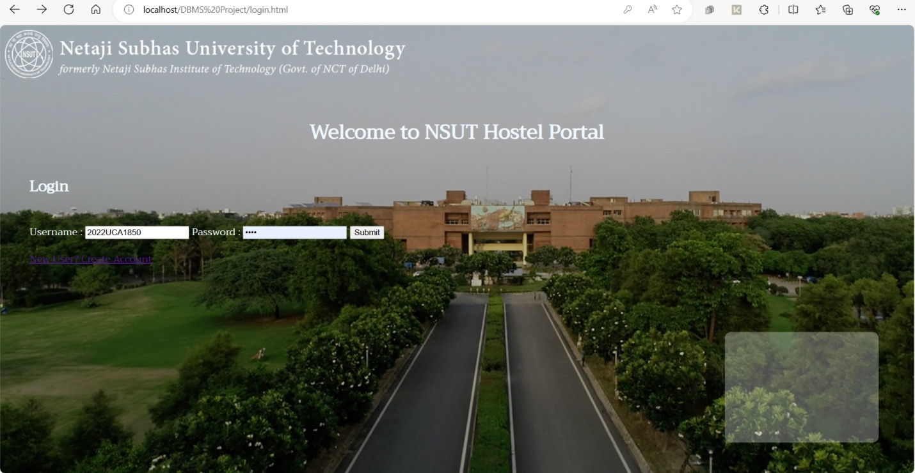

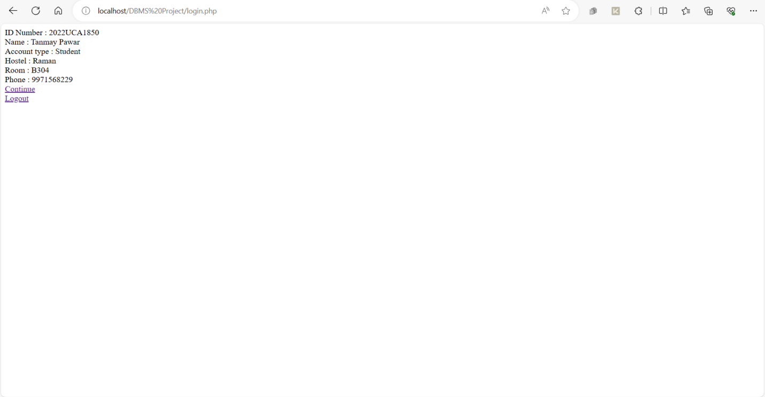

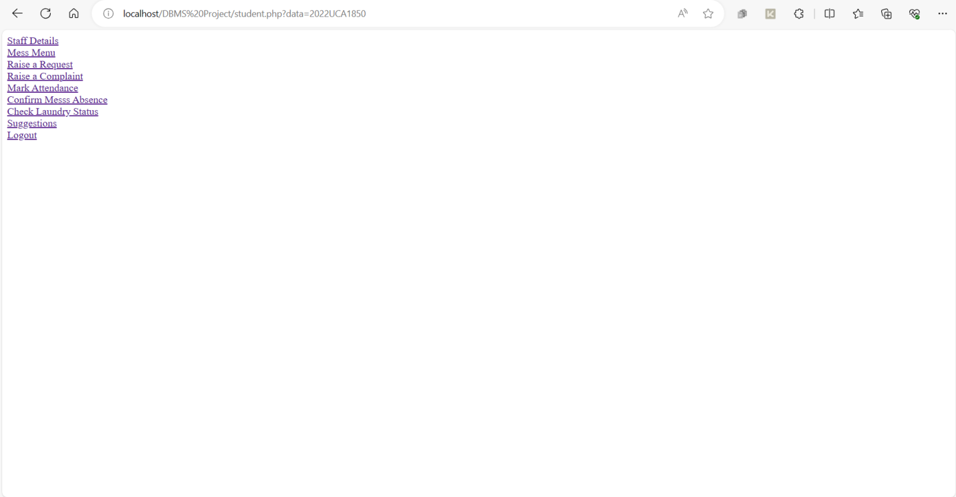

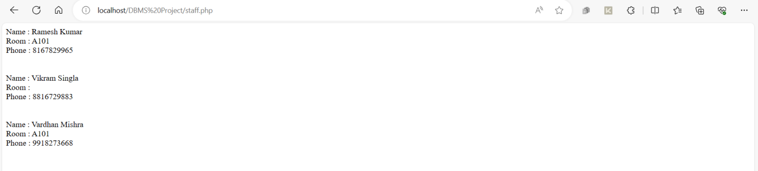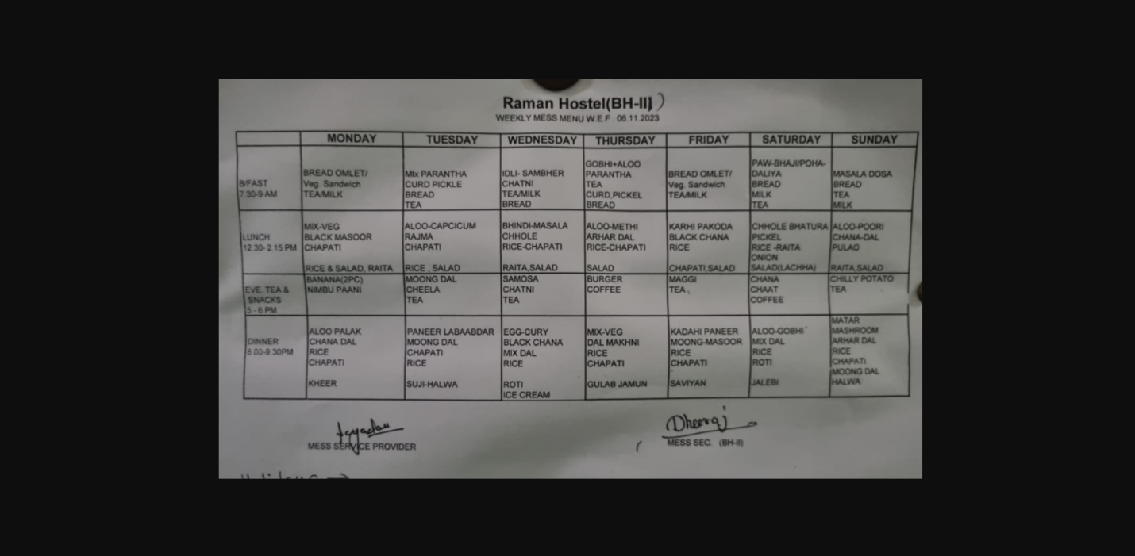

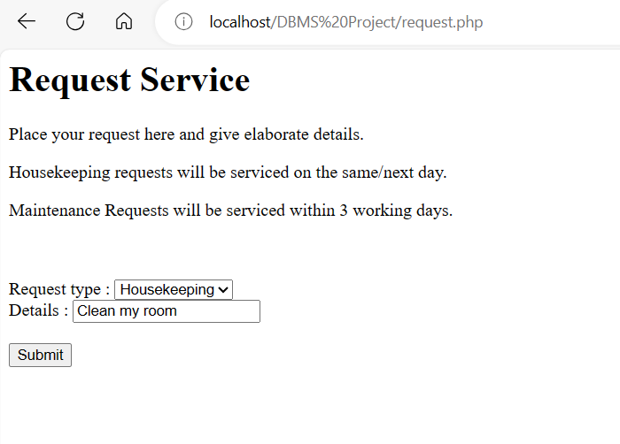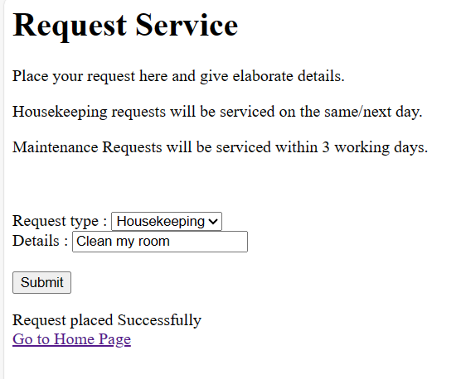

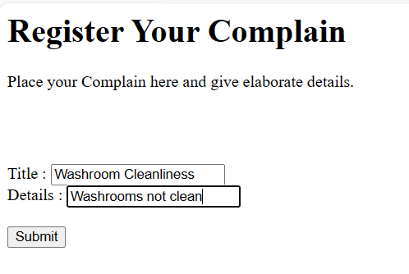

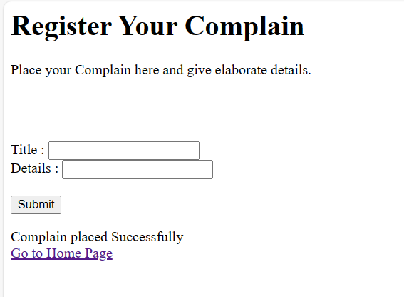

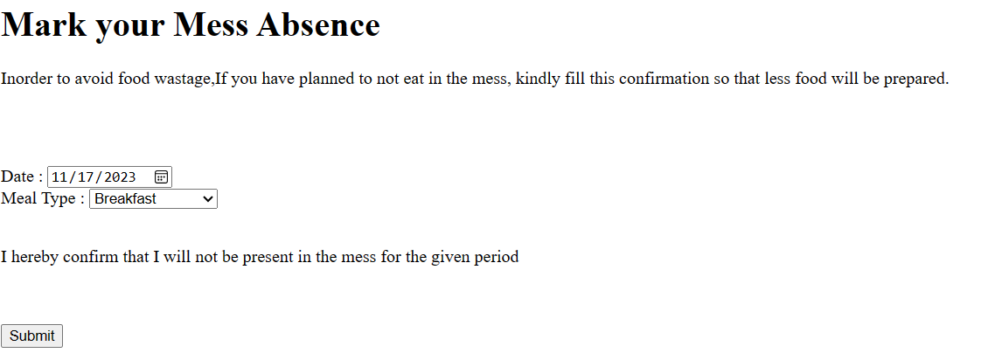

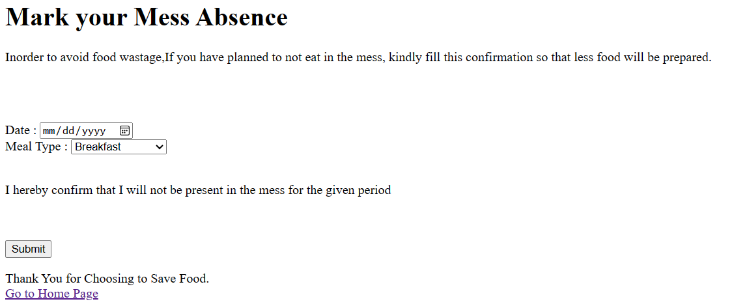

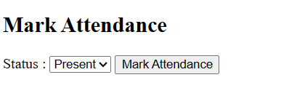

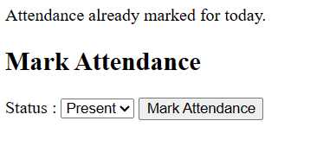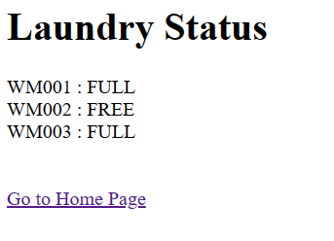

ADMIN STAFF VIEW



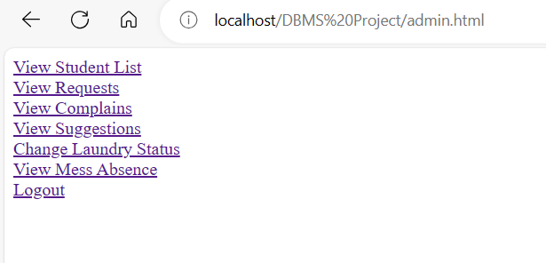

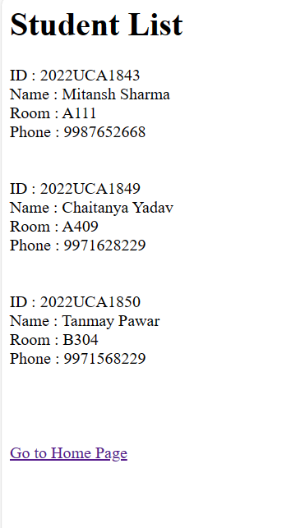

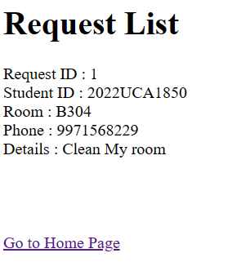

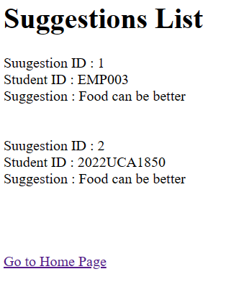

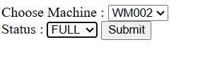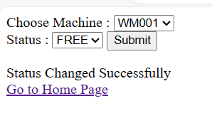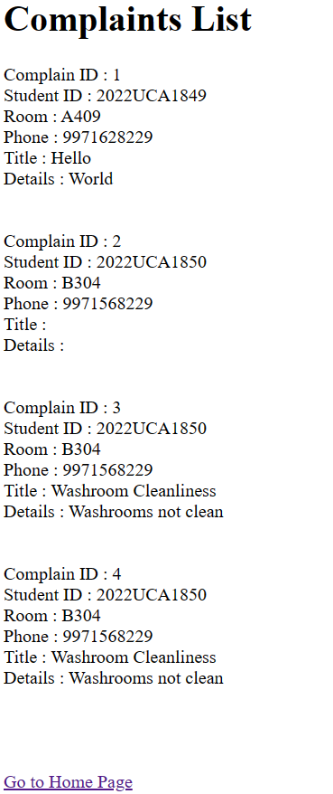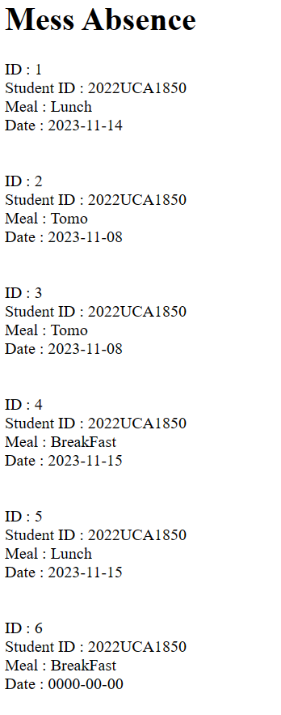

HOUSEKEEPING/MAINTENANCE STAFF VIEW





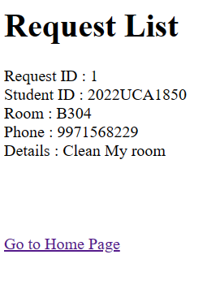

REFERENCES

<https://www.w3schools.com/php/>

Lecture notes

THANK YOU